Hepatitis C
Name
Institution
Course
Date

Hepatitis c
Question One
Sovaldi is an oral nucleotide that acts as an inhibitor of the virus that causes the disease Hepatitis C. Sovaldi belongs to a class of medications called direct-acting antiviral drugs, because it works to treat the Hepatitis C virus (HCV) by blocking the virus from multiplying inside your body. The most similar nucleotide to Sovaldi is the Harvoni which contains the sofosbuvir, the common active drug in both of them (McMurry, 2014). They are both HCV nucleotide analog NS5B polymerase inhibitors. Nucleotide analogs are nucleotides that contain a nucleic acid analogue, a sugar and a phosphate group. Several nucleoside classes have been or continue to be in development as inhibitors of HCV. These classes include the β-D-20-deoxy-20-R-F-20-β-C-methylribose, the β-D-20-β methylribose, and the 40-azidoriboseclasses (Sofia et al. 2010) (Sofia et al. 2010).
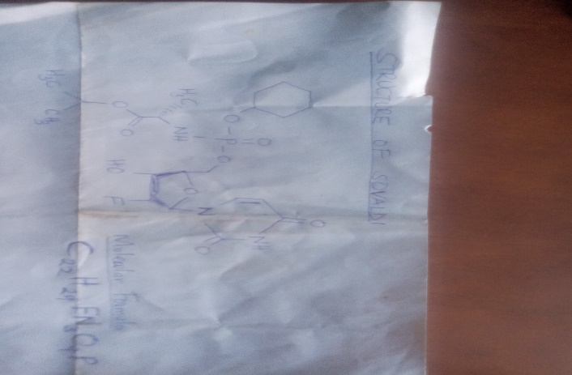
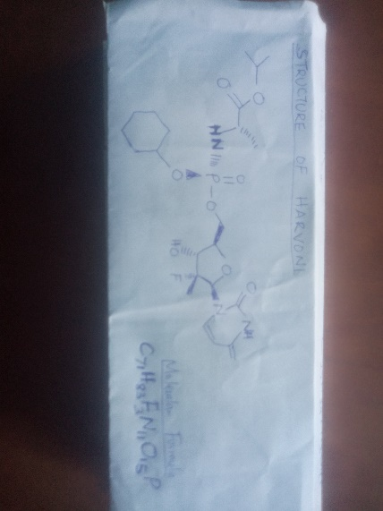

Question 2
An alternative treatment method for Hepatitis as provided in the Medicinal Chemistry Article is the discovery of β-D-20-Deoxy-20-R-fluoro-20-β-C-methyl nucleosides are selective inhibitors of the HCV NS5B polymerase and have demonstrated potent activity in the clinic. Sovaldi works by interfering with the reproduction of the genetic material of the virus that causes Hepatitis C. It inhibits the RNA-dependent polymerase called NS5B which the virus needs for replication or multiplication. Another example of a drug is the ribavirin which is a guanosine analogue which works against several RNA and DNA viruses. Ribavirin has been used for the treatment of chronic Hepatitis C virus by combining it with interferon also known as IFN-alfa. This is because ribavirin alone cannot adequately inhibit viral replication in the cells of infected victims (McMurry et al. 2014). However, ribavirin’s antiviral ability as a single agent has been found to work in four different ways. These are, direct inhibition of the virus replication, inhibiting the host inosine monophosphate dehydrogenase enzyme, modulating the immune system by inducing the immune response and inducing rapid replication of virus by mutagenesis such that it leads to error catastrophe. Ribavirin has little power against HCV alone, but combining it with IFN-alfa releases its power on inhibiting the multiplication of the virus.
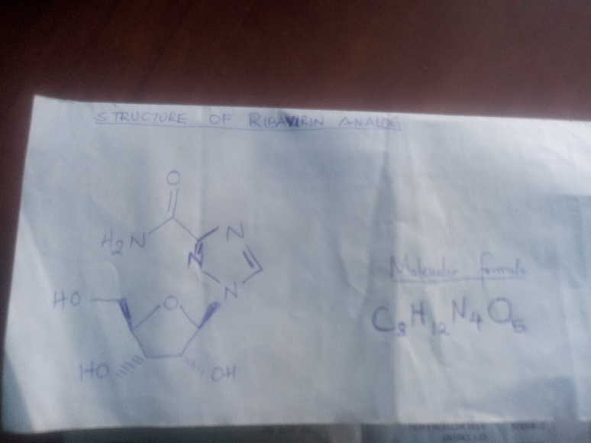
Another example of treatment is combination of ledipasvir and sofosbuvir which has been approved to work better. The mechanism of action involves the inhibition of the non-structural protein 5A in NS5A, which is an essential component in the replication of the Hepatitis C virus (Sofia et al. 2017). NS5A is a viral phosphoprotein which is involved in the secretion, assembly and replication of the Hepatitis C virus. Sofosbuvir, is a uridine triphosphate that acts as the chain terminator of RNA when incorporated into the NS5B polymerase. The ledipasvir /sofosbuvir combination is a direct-acting antiviral agent which works as to interfere with HCV replication hence used for patients with genotype 1a or 1b Hepatitis C.
Question 3
The chemical synthesis of Sovaldi is a process that is based on the dynamic kinetic resolution of an unstable isopropyl-2-((chloro (phenoxy)phosphoryl)-amino) propanoate (8) which yields a very high stereo-selection due to a -OH group (Sofia et al. 2010). Esterification and carbonate-based reactions give inferior stereo-selections while addition of benzyl protective allows for phosphorylation with formation of a triphosphate, favoring the formation of the end product with the right configuration at the stereogenic center. The first stephydrolysis of the carboxylester , is astereo specific reaction catalyzed by and CES1 in primary human hepatocytes .However, it is possible that the other enzymes also play a role in this step (Murakami et al. 2010). The second step involves a rapid chemical reaction of the hydrolyzed product to form PSI-352707, the common phosphonamide intermediate for all three compounds. The third step canbecatalyzedbyHint1, whichconvertsPSI-352707toPSI7411, the5-monophosphate form. The fourth and fifth steps are phosphorylation reactions mediated by UMP-CMPkinase And nucleosidediphosphatekinase, which convertsPSI-7411to PSI-7410 and PSI-7410 to PSI-7409, respectively (12). Stereo specificity of the two isomers occurred at the first hydrolysis step, withPSI-7977 being a better substrate for CatA and PSI7976 for CES1 (Murakami et al. 2010). Once the carboxylestermoiety of these compounds is hydrolyzed, the remaining steps leading to the formation of PSI-7409 are identical.
This process occurs in an 8-step synthesis to produce the drug Sovaldi. The identified processes include, cyclization reaction to the compound forming an inter-product, esterification with addition of benzyl chloride to the inter-product and then dissolving the inter-product in a solvent for purification which produces a sofosbuvir intermediate (Murakami et al. 2010). Enzymatic reactions due to phosphorylation allows for biological conversion of the intermediate product forming a triphosphate.

References
Sofia, M. J., Bao, D., Chang, W., Du, J., Nagarathnam, D., Rachakonda, S., ... & Bansal, S. (2010). Discovery of a β-d-2′-deoxy-2′-α-fluoro-2′-β-C-methyluridine nucleotide prodrug (PSI-7977) for the treatment of hepatitis C virus. Journal of medicinal chemistry, 53(19), 7202-7218.
Murakami, E., Tolstykh, T., Bao, H., Niu, C., Steuer, H. M. M., Bao, D., ... & Otto, M. J. (2010). Mechanism of activation of PSI-7851 and its diastereoisomer PSI-7977. Journal of biological chemistry, 285(45), 34337-34347.
McMurry, J. E. (2014). Organic chemistry with biological applications. Nelson Education.

